Execution Steps:

1. Extract the “ExpenseIt.7z” file
2. Build exe placed in the TestComplete Project folder as mentioned below and added to **TestedApps.**

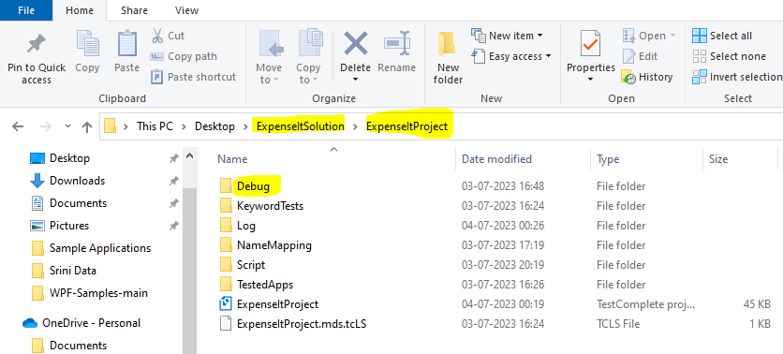

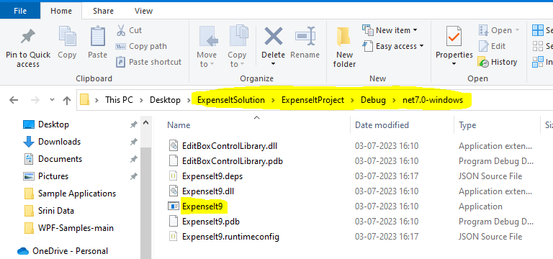

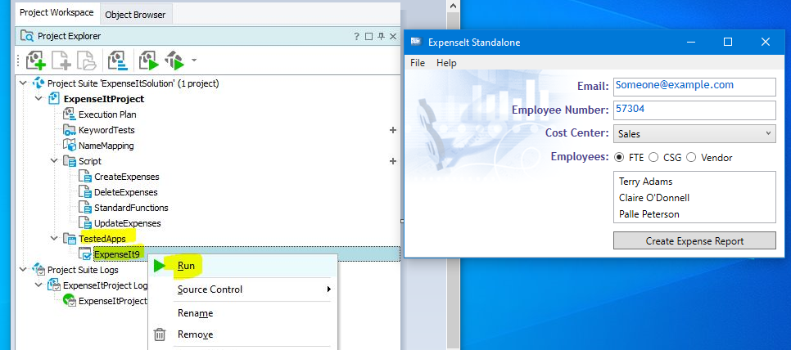

1. Open the Execution plan from Project Explorer and Run the tests from execution plan.

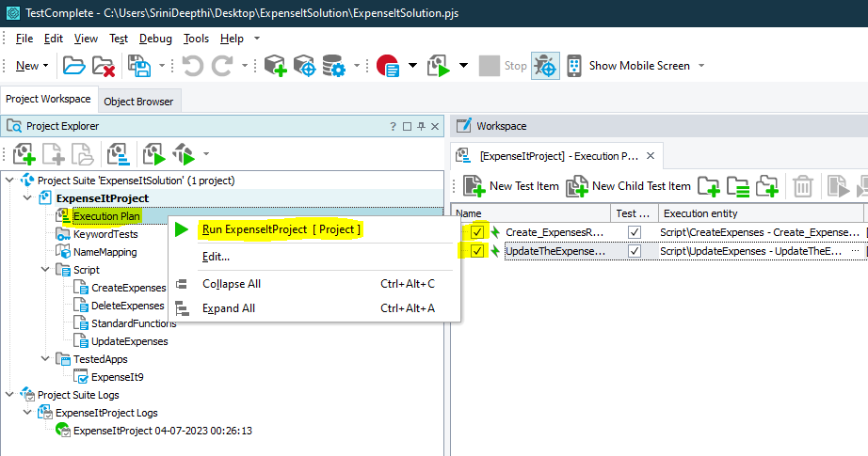

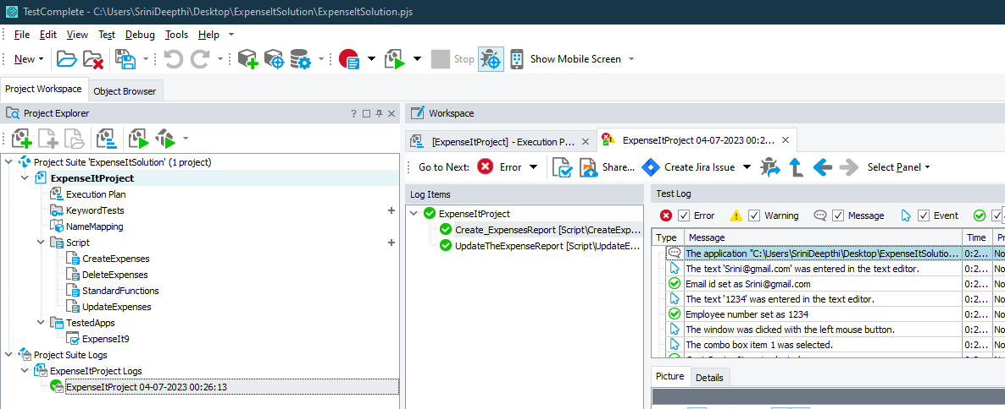

1. Check for the Test results from “Project Suite Logs”



Scenarios Automated:

1. Create t Expense Report
2. Launch the ExpenseIt App.
3. Enter the Expense Details from “Expense Standalone” dialog
4. Click on the ‘Create Expenses Report’ button
5. Click on “Add Expense” button
6. Enter the details in Data grid table for expense details
7. Click on Ok button
8. Click on Ok from message.
9. Update Expense Report
10. Launch the ExpenseIt App.
11. Click on the ‘Create Expenses Report’ button
12. Update the specified Cell values from expenses grid table
13. Click on Ok button
14. Click on Ok from message
15. Delete Expense Report --- *This feature is not available in app.*